14.55: a) The submerged volume 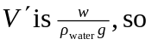

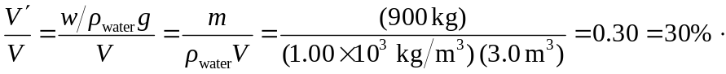

b) As the car is about to sink, the weight of the water displaced is equal to the weight of the car plus the weight of the water inside the car. If the volume of water inside the car is 

